1.Find all the information about each product.
Answer:
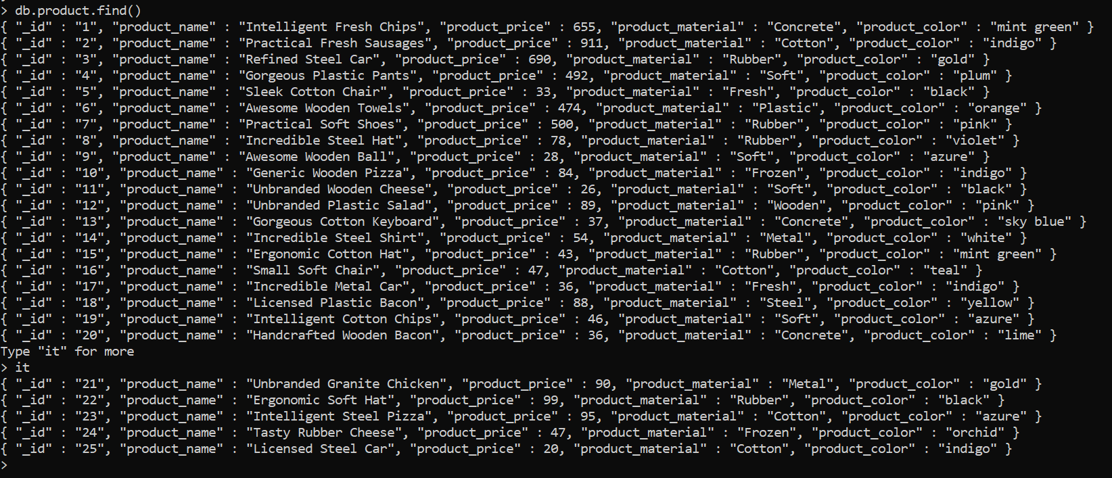

2.Find the product price which are between 400 to 800
Answer:
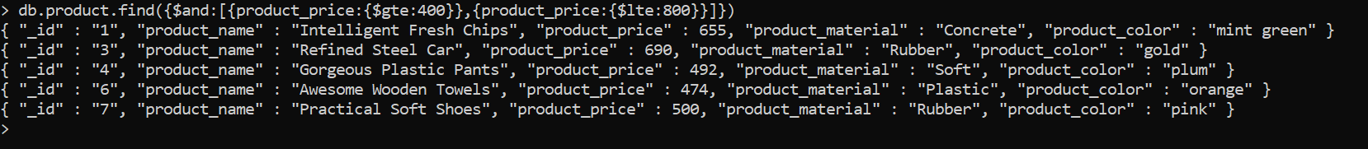

3.Find the product price which are not between 400 to 600
Answer:
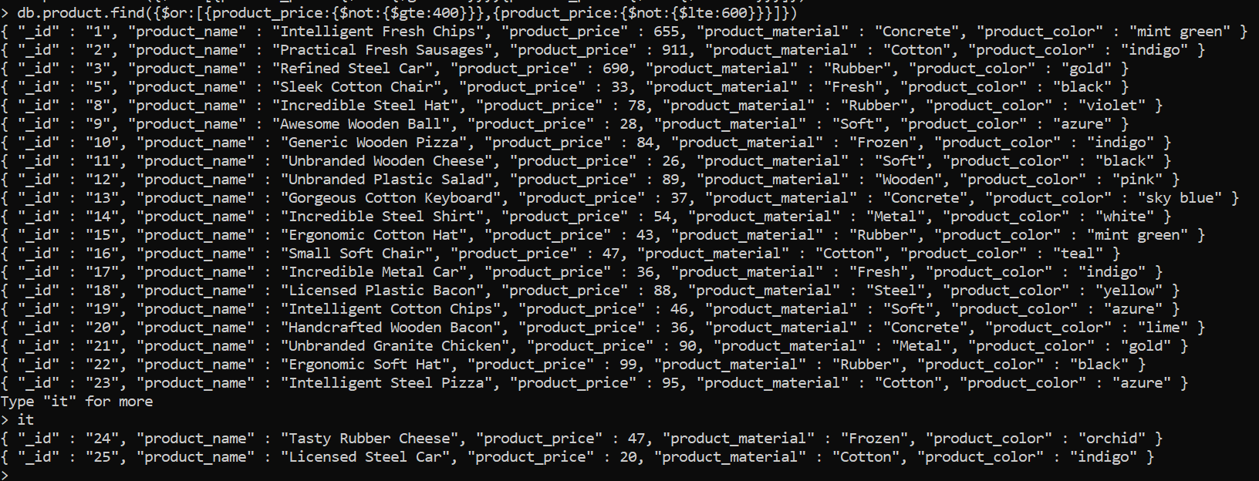

4.List the four product which are grater than 500 in price
Answer:

5.Find the product name and product material of each products
Answer:
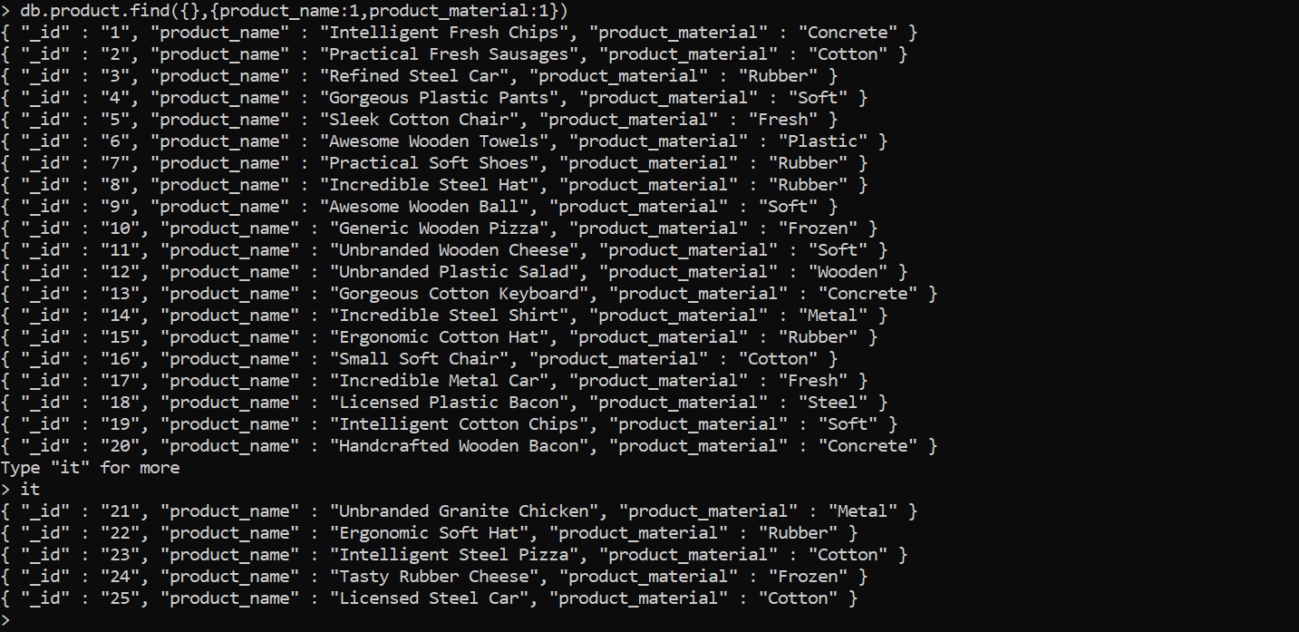

6. Find the product with a row id of 10
Answer:

7.Find only the product name and product material
Answer:
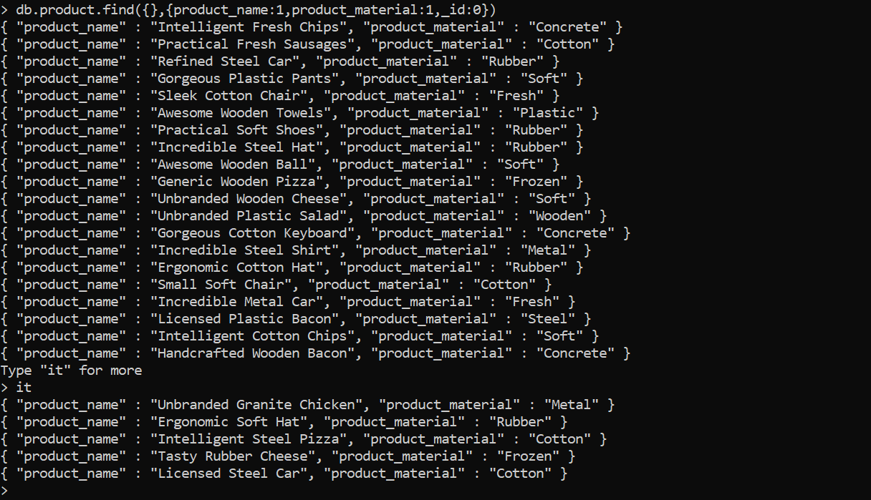

8.Find all products which contain the value of soft in product material
Answer:
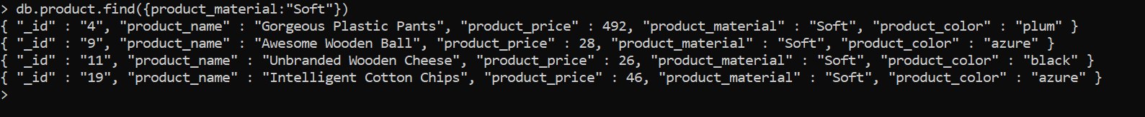

9.Find products which contain product color indigo and product price 492.00
Answer:

10. Delete the products which product price value are same
Answer:
